**CENWP-ODJ1/4/2023**

**MEMORANDUM FOR THE RECORD**

**SUBJECT: *22JDA21 MFR Sheen Observed in JDA Upstream Gatewells 2A and 4B***

On 29 December 2022 at approximately 1030, Fisheries personnel reported seeing a sheen in Bulkhead slot 2A. Fisheries personnel alerted Operations and EHS. EHS and Chief of Operations investigated and were able to see dispersed areas of sheen in both bulkhead slot 2A and 4B. Due to lack of work in area, the source of the sheen was unknown and determined to be possibly biological. JDM personnel were alerted and an attempt to recover sheen was made using absorbs. JDM personnel continue to investigate and attempt to discover the source of the sheen.

Bulkhead slots are separated from the river but hydraulically connected and oil spills to them are reported as a discharge.

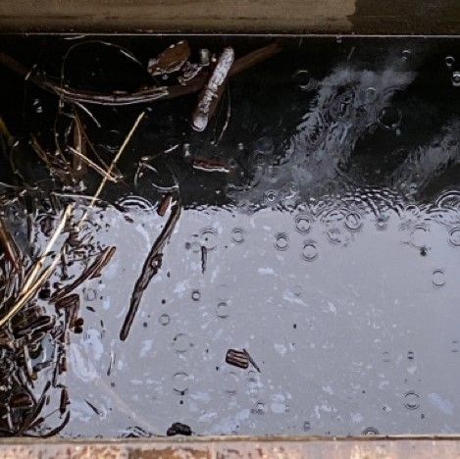

1. Species –
2. Origin – NA
3. Length – NA
4. Marks and tags – NA
5. Marks and Injuries found on carcass – NA
6. Cause and Time of Death – NA
7. Future and Preventative Measures –The cause is unknown, gatewell inspections will continue at JDA.

Sincerely, Project Fisheries